Computer Science 2212b

Team Assignment 3

Team 10

Due: March 15th, 2014 at 11:59 PM

**Team Members:**

Henrique Brighenti

Will Callaghan

Alex MacLean

Stephen Solis

Marcus Tonogai

**SECTION 1: REVISED UML CLASS DIAGRAM**

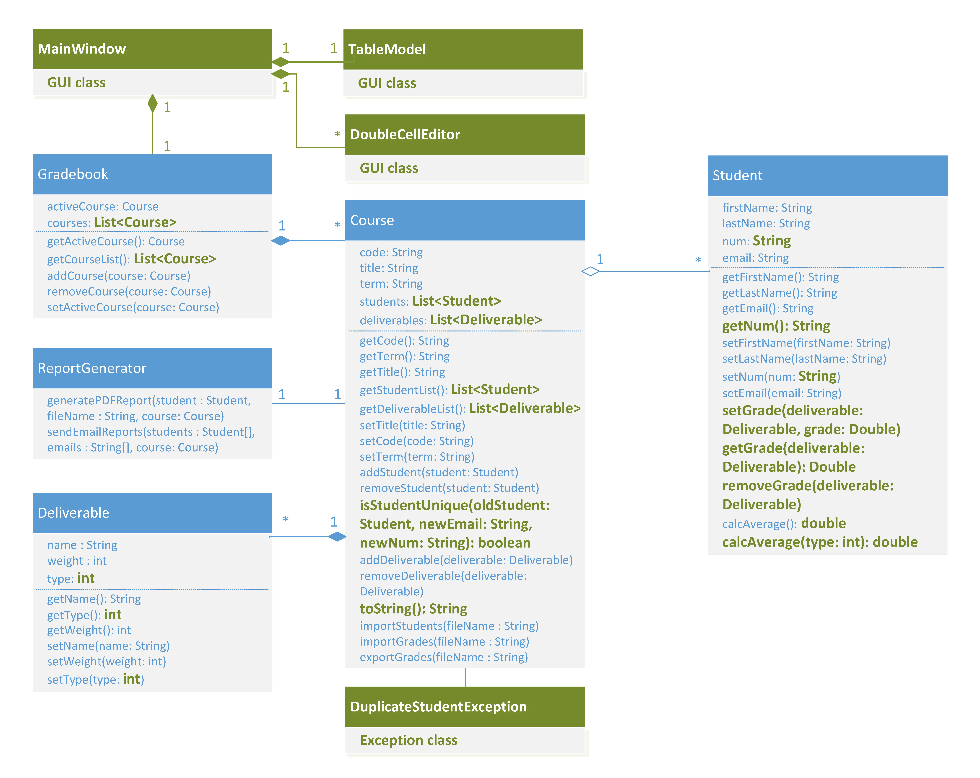

**SECTION 2: REVISED USER STORIES**

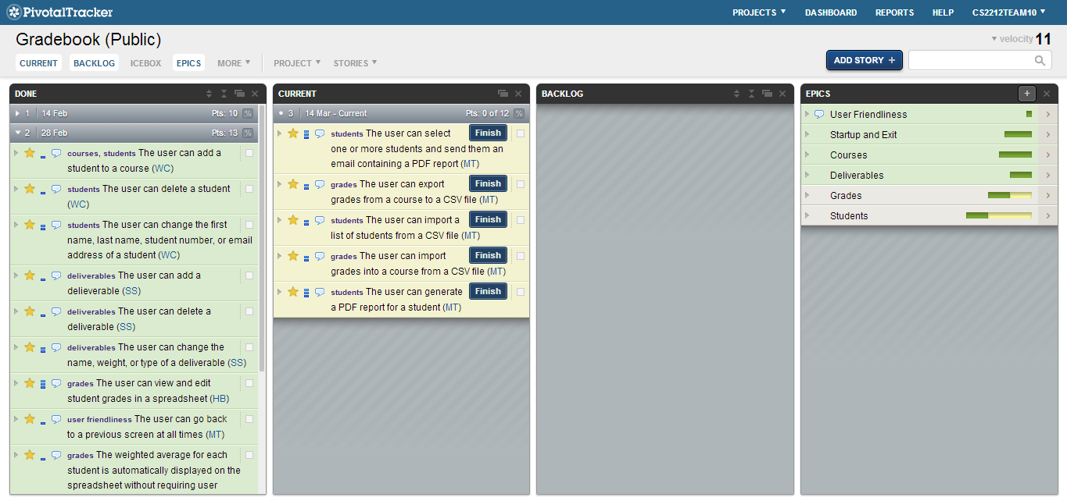

<https://www.pivotaltracker.com/s/projects/1003292>

**Completed User Stories:**

* User can add a course
  + Hit the first icon underneath File menu in the top left or go to the courses menu and hit “Add Course”
* User can delete a course
  + Hit the third icon underneath the File menu in the top left or go to the courses menu and hit “Delete Course”
* User can change the code, title, or term of a course
  + The middle icon below the File and Courses menus will allow a user to edit a course or got to the Courses menu and click “Edit Course”
* User can change the active course
  + Use the drop down menu in the top right to select an active course
* User’s data is retrieved and restored whenever the system is started
  + Make some changes, close the program, then open it again.
* User can add a student
  + Make sure you’ve created a course
  + Go to the student menu and click “Add Student”
* User can delete a student
  + Select any cell on the row of the student you want to delete, then go to the student menu and click “Delete Student”
  + Or, right click on the student name or number and select “Delete Student”
* User can change the first name, last name, student number, or email address of a student
  + Select any cell on the row of the student you want to edit, then go to the student menu and click “Edit Student”
  + Or, right click on the student name or number and select “Edit Student”
* User can add a deliverable
  + Make sure you’ve created a course
  + Go to the deliverable menu and click “Add Deliverable”
* User can delete a deliverable
  + Select any cell on the column of the deliverable you want to delete, then go to the deliverable menu and click “Delete Deliverable”
  + Or, right click on any cell on the column of the deliverable and select “Delete Deliverable”
* User can change the name, weight, or type of a deliverable
  + Select any cell on the column of the deliverable you want to edit, then go to the deliverable menu and click “Edit Deliverable”
  + Or, right click on any cell on the column of the deliverable and select “Edit Deliverable”
* User can view and edit student grades in a spreadsheet
  + To edit grades, just click on them, press enter after editing.
* The weighted average for each student is automatically displayed on the spreadsheet without requiring user interaction
  + Done automatically.

**SECTION 3: ACCEPTANCE TESTING**

|  |
| --- |
| **ID** 1 |
| **Testing**  User adding a new course; no course code |
| **References**  Requirement 4.2.1.a |
| **Test Case**  1. Enter nothing for the course code |
| **Expected Output**  Error.  Message: Invalid course code: course code is blank |

|  |
| --- |
| **ID**  2 |
| **Testing**  User adding a new course; no course title |
| **References**  Requirement 4.2.1.b |
| **Test Case**  1. Enter nothing for the course title |
| **Expected Output**  Error.  Message: Invalid course title: course name is blank |

|  |
| --- |
| **ID**  3 |
| **Testing**  User adding a new course; no course term |
| **References**  Requirement 4.2.1.c |
| **Test Case**  1. Enter nothing for the course name |
| **Expected Output**  Error.  Message: Invalid course term: course term is blank |

|  |
| --- |
| **ID**  4 |
| **Testing**  User editing an existing student; no first name |
| **References**  Requirement 4.3.1.a |
| **Test Case**  1. Enter nothing for the student’s first name |
| **Expected Output**  Error.  Message: Invalid student first name: first name is blank |

|  |
| --- |
| **ID**  5 |
| **Testing**  User editing an existing student; no last name |
| **References**  Requirement 4.3.1.b |
| **Test Case**  1. Enter nothing for the student’s last name |
| **Expected Output**  Error.  Message: Invalid student last name: last name is blank |

|  |
| --- |
| **ID**  6 |
| **Testing**  User editing an existing student; no email address |
| **References**  Requirement 4.3.1.d |
| **Test Case**  1. Enter nothing for the student’s email address |
| **Expected Output**  Error.  Message: Invalid student email address: email address is blank |

|  |
| --- |
| **ID**  7 |
| **Testing**  User editing an existing student; no student number |
| **References**  Requirement 4.3.1.c |
| **Test Case**  1. Enter nothing for the student’s student number |
| **Expected Output**  Error.  Message: Invalid student number: student number is blank |

|  |
| --- |
| **ID**  8 |
| **Testing**  User editing an existing student; duplicate student number |
| **References**  Requirement 4.3.1.c |
| **Test Case**  1. Create two new students with the same student number |
| **Expected Output**  Error.  Message: Invalid student number: student number already exists |

|  |
| --- |
| **ID**  9 |
| **Testing**  User editing an existing student; duplicate email address |
| **References**  Requirement 4.3.1.d |
| **Test Case**  1. Create two new students with the same email address |
| **Expected Output**  Error.  Message: Invalid student email address: email address already exists |

**SECTION 4: JENKINS CI**

URL: http://ec2-54-227-195-219.compute-1.amazonaws.com/

Username: ta

Password: cs2212

**SECTION 5: PROJECT PLAN DOCUMENTATION**



